# Flow

Required:

1. List of MR Data to be migrate
2. CD ID already migrated to the DPM portal
3. DPM Account

## Create MR Bulk

1. Open & Login to BAM. Link: <https://bam-id.e-dpm.com>
2. Click menu MR List, then click button Create MR Bulk  
   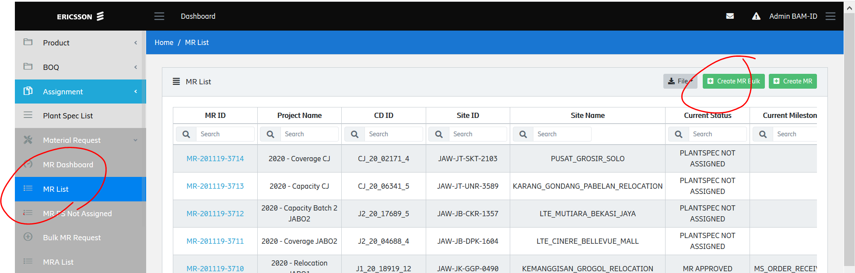
3. Click Download MR Format and open the Excel file template.  
   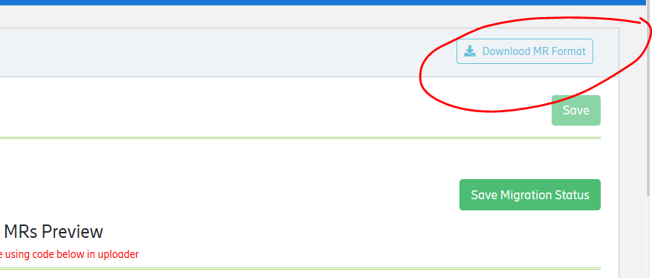
4. Fill the template. You need to mapping the field from MR Sitehandler DRT to the template  
   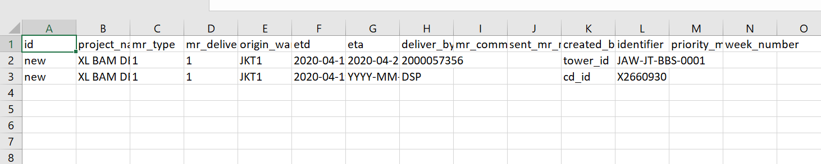
5. Attach the file, then the system automatically check your data.   
   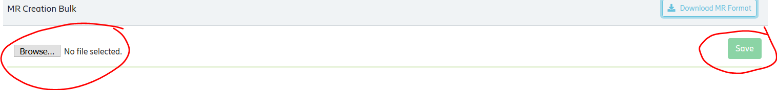
6. Click save to start upload the data.

## Download MR List

1. Open MR List menu, then Download MR List  
   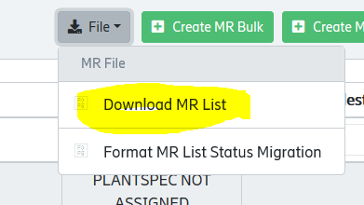
2. Filter your data using Creation date in MR ID & CD ID  
   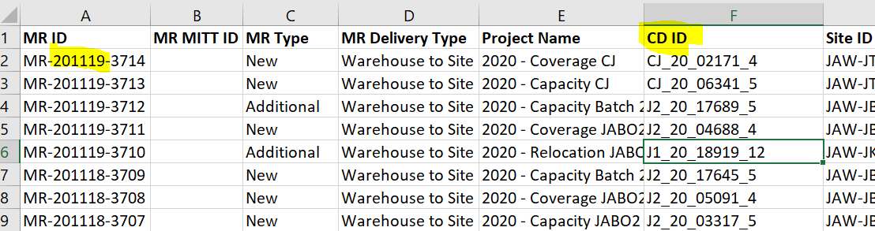

## Update the MR with Sitehandler Data

1. Open the MR List, then download Format MR List Status Migration.  
   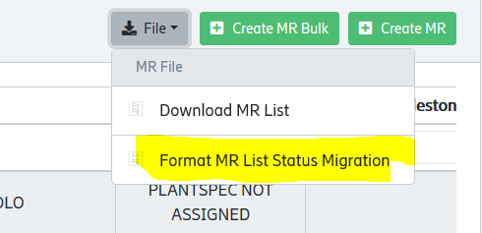
2. Open the file, delete the row data then fill the data from Sitehandler DRT  
   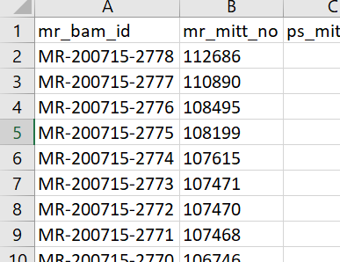
3. You can upload the in MR List 🡪 Create MR Bulk ->Migration Status from SH 